

**Year 11 Biology ATAR – Unit 1**

**Test 1 – Biodiversity & Classification**

|  |
| --- |
| Name: |

|  |  |  |
| --- | --- | --- |
|  | Marks Available | Marks Achieved |
| Part 1 - Multiple choice | 15 |  |
| Part 3 - Short Answer | 30 |  |
| Part 3 – Extended Response | 10 |  |
| Total | 55 |  |

Assessment Time: 55 minutes

Weighting: 20%

**Section One: Multiple choice (15 Marks)**

Mark your answers on the grid below with a X.

|  |  |  |  |  |
| --- | --- | --- | --- | --- |
| Question |  |  |  |  |
| **1** | **A** | **B** | **C** | **D** |
| **2** | **A** | **B** | **C** | **D** |
| **3** | **A** | **B** | **C** | **D** |
| **4** | **A** | **B** | **C** | **D** |
| **5** | **A** | **B** | **C** | **D** |
| **6** | **A** | **B** | **C** | **D** |
| **7** | **A** | **B** | **C** | **D** |
| **8** | **A** | **B** | **C** | **D** |
| **9** | **A** | **B** | **C** | **D** |
| **10** | **A** | **B** | **C** | **D** |
| **11** | **A** | **B** | **C** | **D** |
| **12** | **A** | **B** | **C** | **D** |
| **13** | **A** | **B** | **C** | **D** |
| **14** | **A** | **B** | **C** | **D** |
| **15** | **A** | **B** | **C** | **D** |

**Part 1: Multiple Choice**

1. Scientists describe biodiversity as:

1. all of the endangered species from a particular part of the world.
2. the variety of life on Earth.
3. the study of living systems and how diverse they are.
4. the study of cellular processes and how they vary.

2. In which of the following would you expect to find the least biodiversity?

1. An Australian rainforest containing a variety of habitats
2. A population of koalas in an Australian zoo that arose from one breeding pair
3. The population of green turtles breeding on Raine Island in the Great Barrier Reef
4. A eucalypt forest regenerating 2 years after a fire

3. The Baikal seal is a species of earless seal found only in the fresh water of Lake Baikal in Siberia, Russia. The fact that it lives nowhere else means it is an example of:

1. a phylogenetic species.
2. an endemic species.
3. a morphological species.
4. an introduced species.

4. The structure and organisation of ecosystems are affected by which of the following biotic factors?

(a) Nutrient availability, soil pH, temperature

(b) Predation, competition, disease

(c) Light intensity, rainfall, population dynamics

(d) Temperature, predation, amount of fresh water

5. Which of the following features is not associated with Domain Eukaryota?

1. Organisms in this domain can be found just about everywhere.
2. Some organisms in this domain can produce their own food through photosynthesis.
3. Organisms in this domain can be unicellular or multicellular.
4. Organisms in this domain do not have membrane bound organelles.

6.  The division of life into Domains is based on:

1. cellular characteristics, including the presence of DNA contained within a nucleus.
2. cellular characteristics, including living in extreme environments such as areas of high temperature.
3. similarity of physical features, such as colour and shape of the organisms.
4. differences between physical features, such as colour and shape of the organisms.

7. Sea sponges, earthworms, march flies, and echidnas are all classified into the same:

1. Family.
2. Genus.
3. Phylum.
4. Kingdom.

8. The diagram shows the divergence of lineages in the evolution of some primates. 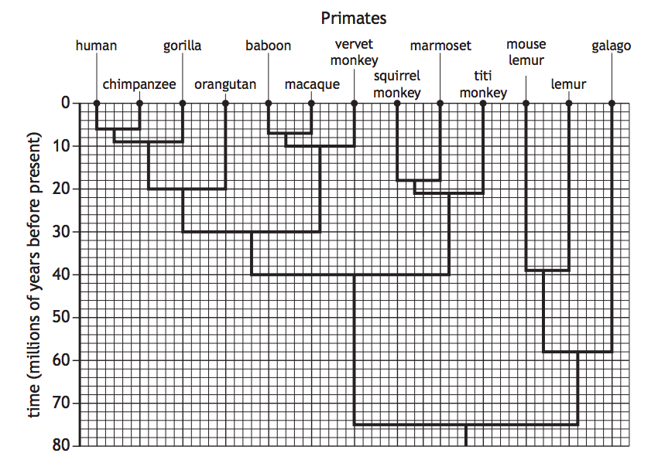

Which row of the table identifies the time that the last common ancestor of vervet monkeys and humans existed, and the number of other species that shared this common ancestor?

|  |  |  |
| --- | --- | --- |
|  | Time (millions of years before present) | Number of other species that shared this common ancestor |
| a) | 30 | 5 |
| b) | 30 | 11 |
| c) | 40 | 8 |
| d) | 75 | 11 |

9. Bufo marinus is a toad native to the Americas. In Australia, we know this animal as a cane toad. Which part of its scientific name tells scientists the genus of the cane toad?

1. Bufo
2. marinus
3. Neither Bufo nor marinus
4. Both the words Bufo and marinus are required to determine the genus.

10. Organisms in the Cnidarian phyla have

1. have bilateral symmetry.
2. have cell walls made of chitin.
3. are able to photosynthesise.
4. Have radial symmetry.

11. There are several animals known commonly as Moles. Marsupial Moles, *Notoryctes typhlops*, is a marsupial found in southern Australia. The Golden Mole, *Chrysochloris asiatica*, is a placental mammal from Southern Africa. These two Moles:

1. are very closely related because they are both types of mole.
2. are only distantly related because they reproduce in different ways.
3. are different species, but are from the same genus.
4. are similar in appearance, so would be able to reproduce fertile offspring if they were in the same habitat.

Question 12 refers to the table below.

|  |  |  |  |  |  |
| --- | --- | --- | --- | --- | --- |
| **Organism** | **A** | **B** | **C** | **D** | **E** |
| Order | Marsupalia | Marsupalia | Carintae | Carnivora | Carnivora |
| Species | Thylacinus cynocephalus | Dasyurus geoffroii | Troglodytes troglodytes | Felis tigris | Felis domesticus |
| Common Name | Tasmanian tiger | Tiger-cat | Wren | Tiger | Cat |

12. Which of the organisms described above would be the most similar?

1. A and D
2. A and C
3. B and E
4. D and E

13. Of the cladograms shown below, which one shows a different evolutionary history from the others?

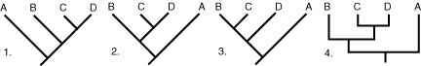

1. b) c) d)

14. The statement below gives information on a plant species.

1 *Solanum lycopersicum* has a vascular structure to its leaves and stem.

2 *Solanum lycopersicum* has seeds.

3 *Solanum lycopersicum* uses fruit to disperse its fertilised seeds.

From this information, which plant phyla does *Solanum lycopersicum* belong to?

1. Ferns
2. Mosses
3. Gymnosperms
4. Angiosperms

15. Using the phylogenetic tree (right), which of the

following organisms are more closely related?

1. 1 and 2
2. 2 and 3
3. 3 and 4
4. 4 and 5

**Part 2: Short Answer**

**Question 16 (4 marks)**

a) List, in order from the smallest group to the largest group, the taxonomical hierarchy of classification. (1 mark)

_________________________________________________________________________

b) Which taxonomical level contains organisms that are most similar?  (1 mark)

_________________________________________________________________________

c) Give two advantages of using this system over using common names. (2 marks)

____________________________________________________________________________________________________________________________________________________________________________________________________________________________________________________________________________________________________

**Question 17 (2 marks)**

List two biotic and two abiotic factors/features that would be present in a polar ecosystem.

__________________________________________________________________________________________________________________________________________________

**Question 18 (5 marks)**

Define the following two species concepts: biological species concept and phylogenetic species concept. Provide an example that supports each species concept. Explain why the biological species concept cannot be used with fossils. _________________________________________________________________________

_________________________________________________________________________

_________________________________________________________________________

_________________________________________________________________________

_________________________________________________________________________

_________________________________________________________________________

**Question 19 (6 marks)**

Examine the dichotomous key presented below and answer the questions which follow. It is used to classify insects to the taxa Order.

**Dichotomous key to insect Orders**

|  |  |  |
| --- | --- | --- |
| 1a | Wings present | Go to 2 |
| 1b | Wings absent | Order Apterygota |
| 2a | With one pair of wings | Order Diptera |
| 2b | With two pairs of wings | Go to 3 |
| 3a | Front wings of coarser texture than hind wings | Go to 4 |
| 3b | All wings membranous. May be hair or scale covered | Go to 8 |
| 4a | Basal two-thirds of front wing thickened, remainder membranous | Order Hemitera |
| 4b | Whole of front wing of same texture | Go to 5 |
| 5a | Front wings hard and horny | Order Coleoptera |
| 5b | Front wings slightly thickened with distinct veins | Go to 6 |
| 6a | Mouthparts of piecing type | Order Hemiptera |
| 6b | Mouthparts of biting type | Go to 7 |
| 7a | Hind legs much longer than other legs | Order Orthoptera |
| 7b | All legs more or less equal in length | Order Blattodea |
| 8a | Wings and body completely covered by fine scales or hairs | Go to 9 |
| 8b | Wings only covered by fine scales or hairs | Order Plecoptera |
| 9a | Hind and front wings linked by a row of hooks. Front of abdomen narrowed to form a ‘waist’ | Order Hymenoptera |
| 9b | Wings not joined. No ‘waist’ | Order Lepidoptera |

The diagram presented below illustrates an animal from the class Insecta. Use the dichotomous key above and this labelled diagram to assist you to answer parts (a) and (b) below.

Coarse front wings (same texture throughout) Smooth hind wings

With thickened and distinct veins

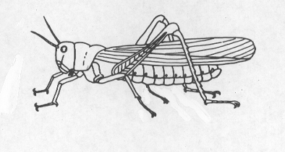

Biting mouth parts

a) Which Order does this insect belong to? ____________________ (1 mark)

b) State three features possessed by this insect. (3 marks)

____________________________________________________________________________________________________________________________________________________________________________________________________________________________________________________________________________________________________

c) Identify two features that Coleoptera and Hemiptera share. (2 marks)

___________________________________________________________________________________________________________________________________________________________________________________________________________________________

**Question 20**  **(3 marks)**

Compare and contrast the features of organisms that belong to the phylum Cordata and phylum Arthropoda.

___________________________________________________________________________________________________________________________________________________________________________________________________________________________

___________________________________________________________________________________________________________________________________________________________________________________________________________________________

___________________________________________________________________________________________________________________________________________________________________________________________________________________________

__________________________________________________________________________________________________________________________________________________

**Question 21 (10 marks)**

a) The table below shows the common and scientific names of five species of fish.

|  |  |
| --- | --- |
| **Common Name** | **Scientific name** |
| Atlantic Herring | *Clupea harengus* |
| Australian Herring | *Arripis georgianus* |
| Cardinal Fish | *Apogon latus* |
| Horse-eye Jack | *Caranx latus* |
| Western Australian Salmon | *Arripis truttaceus* |

b)  What is the genus name of the Atlantic Herring? (1 mark) _________________________________________________________________________

c)  Using their scientific name, which two species in the table are the most closely related to each other? Give a reason for your choice. (3 marks)

____________________________________________________________________________________________________________________________________________________________________________________________________________________________________________________________________________________________________

d) Below is a phylogenetic tree that is missing some of its information.

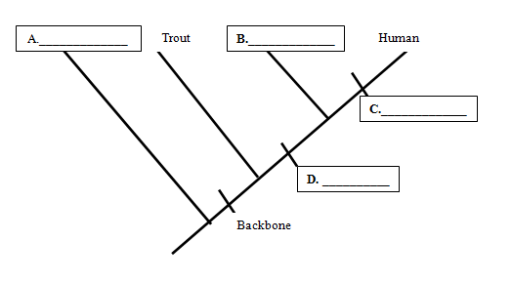Use the derived characteristic matrix below the cladogram to fill in the blanks on the cladogram. (4 marks)

|  |  |  |  |
| --- | --- | --- | --- |
| **Organism** | **Derived Character** | | |
| **Backbone** | **Legs** | **Hair** |
| **Earthworm** | Absent | Absent | Absent |
| **Trout** | Present | Absent | Absent |
| **Lizard** | Present | Present | Absent |
| **Human** | Present | Present | Present |
|  |  |  |  |

e) Which trait separates the least closely related organism from the other animals? (1 mark)

_________________________________________________________________________

f) What is meant by the term ‘common ancestor’? (1 mark)

__________________________________________________________________________________________________________________________________________________

**Part 3: Extended Response**

**Question 22**  **(10 marks)**

In 2019 a new species of baleen whale was identified and described in the Gulf of Mexico. The population of the whale has since been estimated at around 100 individuals.

Demonstrate your understanding of taxonomy and explain the process that biologists would have used to classify the creatures as a new species of baleen whale.

____________________________________________________________________________________________________________________________________________________________________________________________________________________________________________________________________________________________________

____________________________________________________________________________________________________________________________________________________________________________________________________________________________________________________________________________________________________

____________________________________________________________________________________________________________________________________________________________________________________________________________________________________________________________________________________________________

____________________________________________________________________________________________________________________________________________________________________________________________________________________________________________________________________________________________________

____________________________________________________________________________________________________________________________________________________________________________________________________________________________________________________________________________________________________

____________________________________________________________________________________________________________________________________________________________________________________________________________________________________________________________________________________________________

____________________________________________________________________________________________________________________________________________________________________________________________________________________________________________________________________________________________________

____________________________________________________________________________________________________________________________________________________________________________________________________________________________________________________________________________________________________

____________________________________________________________________________________________________________________________________________________________________________________________________________________________________________________________________________________________________

____________________________________________________________________________________________________________________________________________________________________________________________________________________________________________________________________________________________________

____________________________________________________________________________________________________________________________________________________________________________________________________________________________________________________________________________________________________

____________________________________________________________________________________________________________________________________________________________________________________________________________________________________________________________________________________________________

____________________________________________________________________________________________________________________________________________________________________________________________________________________________________________________________________________________________________

____________________________________________________________________________________________________________________________________________________________________________________________________________________________________________________________________________________________________

____________________________________________________________________________________________________________________________________________________________________________________________________________________________________________________________________________________________________

___________________________________________________________________________________________________________________________________________________________________________________________________________________________

**End of Test**